# Lab 3: Javascript

Lab 3. Javascript 1

3.1. Array 2

3.2. Open new window 3

3.3. Count the Function calls 3

3.4. Set controls’ attributes 4

3.5. Add text fields 4

3.6. Validate PostalCode and Money (Regular Expression) 5

3.7. Exercise 1 - Event Handling 5

3.8. Exercise 2– Inheritance 5

3.9. Exercise 3 - DOM 6

3.10. Exercise 4 – Validate inputs 6

## Array

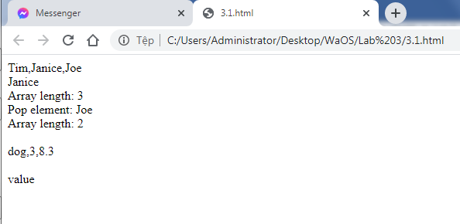

## Open new window

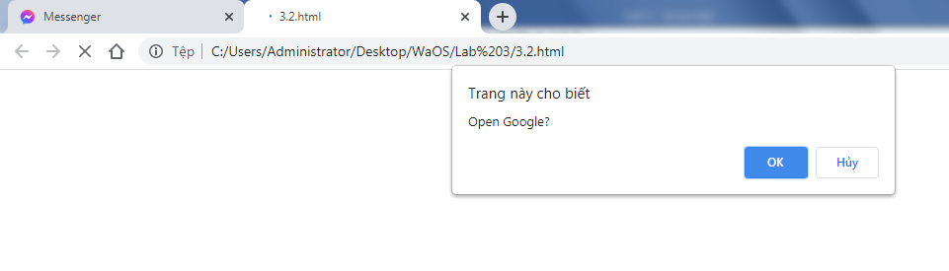

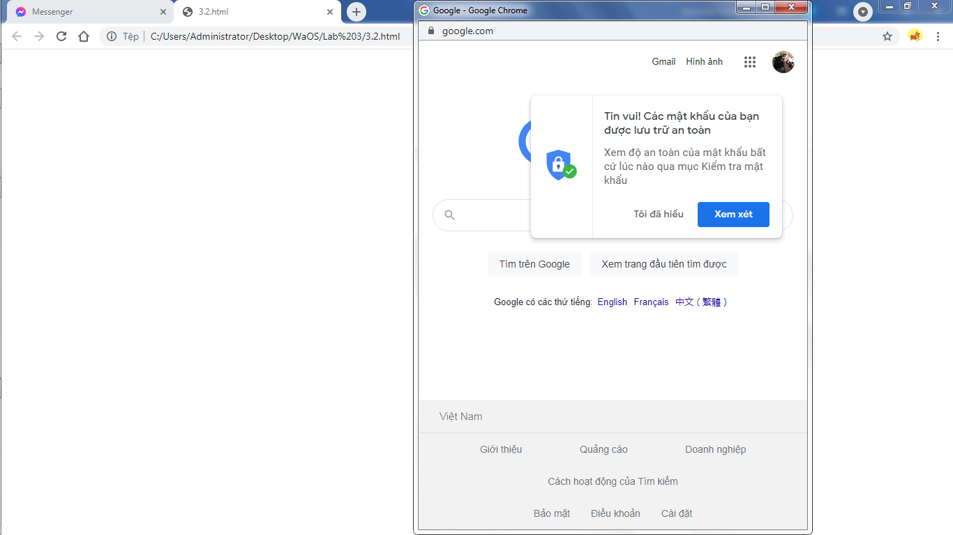

## Count the Function calls

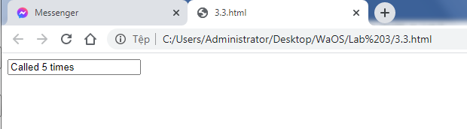

## Set controls’ attributes

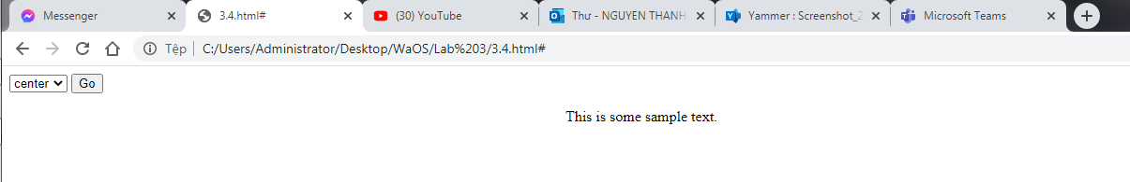

## Add text fields

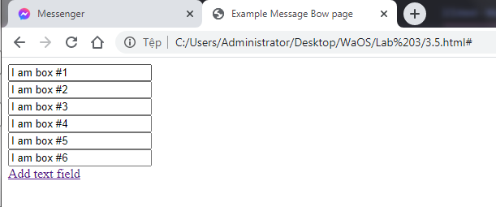

## Validate PostalCode and Money (Regular Expression)

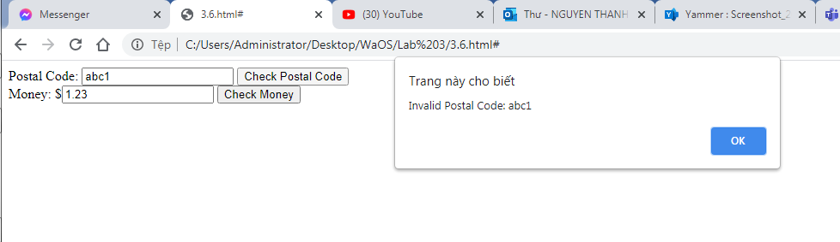

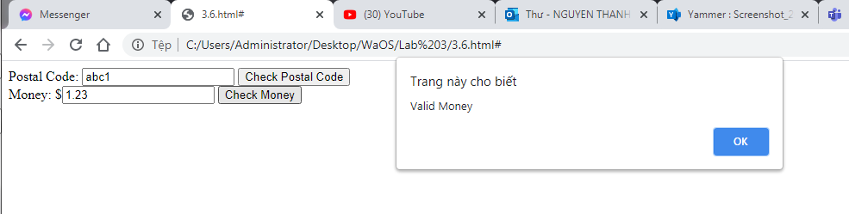

## Exercise 1 - Event Handling

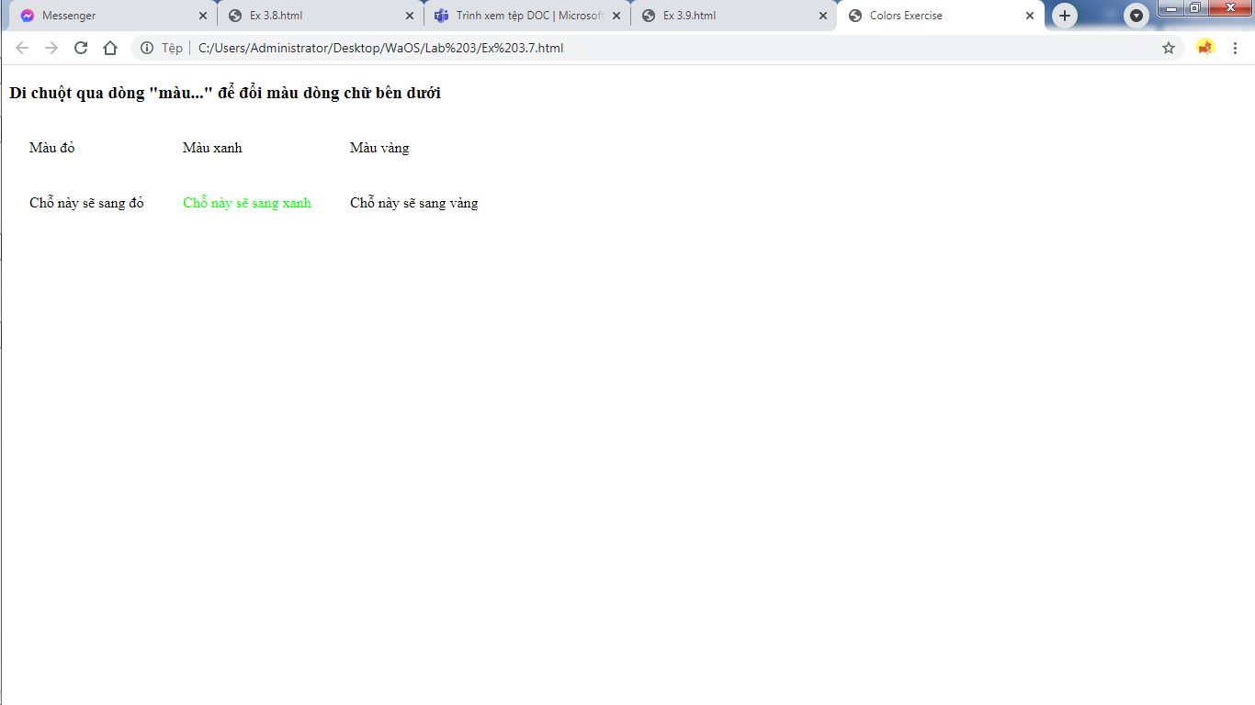

## Exercise 3 – DOM

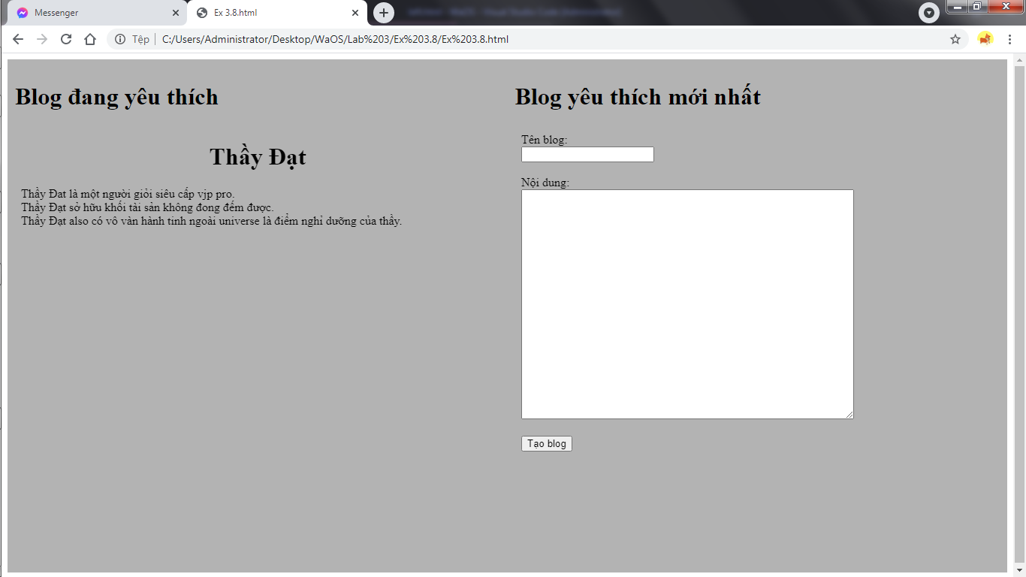

## Exercise 4 – Validate inputs

